

**Department of Software Engineering**

**Faculty of Computer Science & Information Technology**

**The Superior University, Lahore**

**Name:** MUHAMMAD HAMZA ALI

**Roll No:** SU92-BSAIM-S24-032

**Section:** 3A

**Subject:** ARTIFICIAL INTELLIGENCE(LAB)

**Task No:** Lab-Task 4(Task-2)

**Task-4**

**Remove Punctuation From A String**

**1. Introduction:**

This project focuses on a Python program that removes punctuation from a given string. Punctuation marks can sometimes interfere with text processing, and this implementation ensures clean, processed text ouput.

**2. Features:**

The key functionalities of this program include:

* **User Input Handling:** Accepts a string input from the user.
* **Punctuation Removal:** Identifies and removes all punctuation marks.
* **Cleaned Text Output:** Returns and displays the string without punctuation.

**3. Implementation Details:**

The program is implemented using a function remove_punctuation(), which performs the following steps:

1. Define a string containing common punctuation marks.
2. Iterates over each character in the input string.
3. Checks if the character is a punctuation mark.
4. Constructs a new string by excluding punctuation marks.
5. Returns the cleaned string

**4. User Interaction:**

* The user prompted to enter a string.
* The function processes the string and removes any punctuation.
* The cleaned string is displayed to the user.

**5. Example Usage:**

Enter a string: Hello, World!

String without Punctuation: Hello World

Enter a string: Python@Programming#is&fun!

String without Punctuation: PythonProgrammingisfun

**6. Output:**

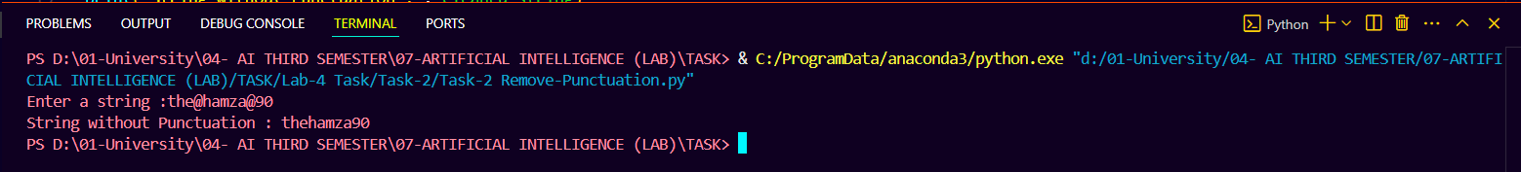

**7. Conclusion:**

The Remove Punctuation program efficiently cleans text by eliminating punctuation marks. This functionality can be useful in natural language processing (NLP) tasks, text preprocessing, and data cleaning. Future enhancements could include support for custom punctuation lists, case-sensitive filtering, or integration with other text processing tools.